Useful information:

- British Heart Foundation
www.bhfactive.org.uk
- Start4life
www.healthyunder5s.nhs.uk

A Parent’s Guide to Physical Development

How to help your 3 to 5 year old build a strong core



Core stability is having strength in the shoulders, pelvis, stomach and back
This is necessary to develop skills in both large and small movement

Floor Play
Give your child lots of opportunities to play on the floor – lying down, propping themselves up and rolling. This will help them to strengthen their core muscles, which in turn improves control of their limbs and small movement skills such as using tools and writing.

- Encourage your child to lie on the floor to do jig-saws, play with toys and read books.
- Give your child a clipboard so that he/she can write and draw in a propped position.
- Make a den by draping sheets over the gaps between furniture
- Show your child how to make a ‘bridge’ – lie on the floor, keep shoulders head and feet on the floor and lift the hips and trunk off the floor.
- Show your child how to roll like a pencil (arms close to sides of body).
- Show your child how to log roll (make a long thin shape with arms above head).

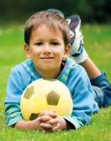

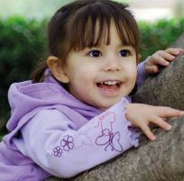

Crawling
Crawling helps to develop head control, balance, core stability, strength in the back, neck, legs, arms, hands and fingers. It supports the development of visual skills and communication between the left and the right sides of the body and the upper and lower parts of the body.

- Make an obstacle course using furniture, boxes etc. for your child to crawl under over or through.
- Pretend to be four legged animals – you could add rhymes and music to this.
- Climbing ladders, cargo nets and trees is vertical crawling.
- Show your child how to kneel on all fours with hands directly under shoulders, hands flat on floor and knees under hips. Lift and stretch out one arm or one leg alternately. When they have mastered this try one arm and the opposite leg at the same time.
- Have a crawling race indoors or on the lawn (a grassy slope is good for racing up).

